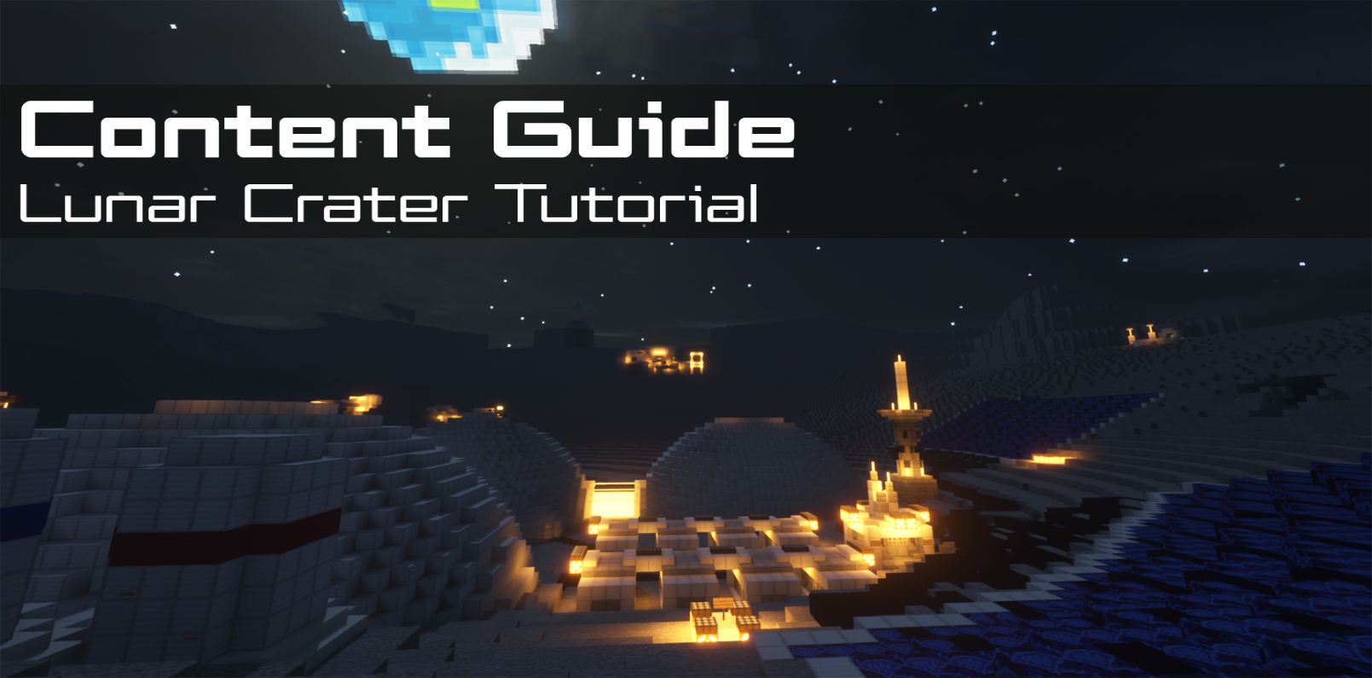
Contents  📖 Narrative Focus 3  🌎 World Overview 3  🎯 Objectives 5  🏫 Standards Alignment 5  📝 Assessments 6  💡 Tips for Instruction 6  🔭 Observable Concepts and Points of Interest 7  ❓ Expected Questions 8  Connected Classroom Activities 8  ☑️ World Quest Progression 8  🗺️ Maps 10  👩🏽‍🔬 NPC's and Their Roles 11 | How to Use This Guide  This content guide is intended for parents, librarians, teachers, and other educators who are interested in facilitating learning experiences with the WHIMC server, in home or classroom-based settings. It reviews all the critical components of a given WHIMC world as well as what might be learned in it.  This world is the second that players encounter, for a full overview of world order, see the teacher guide home page.  More information about project WHIMC can be found on our website at whimc.org. Teachers and participants unfamiliar with computer-based Minecraft: Java Edition can learn how to install and control the game here as well.

📖 Narrative Focus
The Lunar Crater tutorial map, which is largely an introductory world for learners, employs four different, interconnected themes to promote the increasing number of tools and tasks that players will encounter throughout their journey on the WHIMC server. These are:
- Teamwork – Players will feel like they are a part of the organization that runs the moon base. Interactions with different characters, features of the base, and tools they are taught about help promote this idea of teamwork and strong working relationships throughout the base.
- Inspiring Awe – Players will be able to experience the differences the moon offers in relation to Earth, such as jumping around in lower gravity, seeing the earth in the sky and a moon base.
- Connecting to New Knowledge – Developing and maintaining a moon base is a completely new concept to many, and this world within the server exists to teach players what is needed to keep something as substantial as a moon base operational.
- Empowerment – Different quests within the moon base show players that studying and understanding the environments around them could have benefits for science and technology.

🌎 World Overview
This world depicts a lunar settlement has transitioned from a temporary outpost to Permanent Frontier Infrastructure. It represents a step past extreme survival to industrial colonization and features:

Lunar Conditions
- Extreme temperature swings – Lunar daytime temperatures can reach about 250°F (121°C), while nighttime temperatures can drop to around -208°F (-133°C) because the Moon has almost no atmosphere to retain heat.
- No breathable atmosphere – The Moon has only a very thin exosphere, meaning there is no air pressure, no oxygen, and no protection from harmful radiation or meteoroids.
- Intense radiation exposure – Without a magnetic field or thick atmosphere, the lunar surface is bombarded by solar radiation and cosmic rays, making long-term exposure dangerous for humans.
- Micrometeorite impacts – Tiny space rocks constantly strike the surface at high speeds, gradually grinding the lunar soil into abrasive dust called regolith, simulated as Minecraft gravel and stone
- Low gravity environment – The Moon’s gravity is only about 1/6 of Earth’s gravity, which affects movement, human health, and the behavior of dust and equipment

Modular Complex Architecture
Rather than a single vessel acting as a home, the base is a network of specialized modules and domes.
- Zones: Living, working, agricultural and industrial zones are physically separated, with dedicated quarters for sleep, communal areas, supplies management and communications.
- Shielding: To combat long-term radiation and thermal swings, structures are protected with hardened materials or located below ground.
- Safety: The environment features separated landing zones located to prevent exhaust plumes from kicking up dust and damaging the habitat. Separation is reinforced by redundancy of systems to create for a more resilient habitat complex.
- Observatory & Research: Advanced material science labs allow for on-site fabrication and structural analysis, while the lack of atmosphere is leveraged by high-resolution optical telescopes for deep-space observation.

Increasing Resource Autonomy
The defining feature is the move toward In-Situ Resource Utilization (ISRU). The base is no longer relying exclusively on earth.
- Hydrological Harvesting: In our simulation ice is found and stored in a cave (former lava tube) that would have been sheltered from sunlight on the edge of the crater or even inside of lava tubes. Mining operations extract water for drinking and oxygen production. By splitting water, the base acts as a "gas station" in space, refueling ascent vehicles and potentially supporting long-range exploration.
- Food Production: Aquaponics leverage nutrient-rich fish waste fertilize hydroponic crops that, in turn, filter the water. Fungi are cultivated for high-density food sources and waste decomposition, while mycelium-based materials are tested for self-healing structural components.
- Atmospheric Stability: Life support has evolved into robust, redundant mechanical scrubbers supplemented by early-stage experimental greenhouses.

Power Generation
Survival requires overcoming the 14-day lunar night, necessitating a more sophisticated multi-source grid.
- Hybrid Energy: The settlement utilizes massive solar arrays during the day and excess energy is stored in battery banks. The assumption is that efficiency has improved from our modern day capabilities, and some systems, like the construction robot or rover nearby the complex, may rely on independent small nuclear generators. A nuclear reactor is depicted below the engineering area.
- Thermal Management: Large radiator fins shed excess heat during the day, while specialized insulation retains it at night to maintain a delicate equilibrium.

Permanent Crew
Personnel are now residents rather than mere explorers, staying for months or years at a time.
- Rotation and Well-being: This necessitates social survival elements: exercise equipment to mitigate bone loss and semi-private spaces for psychological health.
- Diversified Skillsets: The crew includes administration, miners, engineers, biologists and more, reflecting a shift toward maintaining a functional society rather than just a mission.

🎯 Objectives
- Learn how to use /observe and science tools commands, one of the main functions of WHIMC
- It also presents an opportunity to follow waypoints on their minimap to find NPC’s who will give them quests that relate to science characteristics in the world – this helps them learn how to explore and what to pay attention to
- Students will explore how STEM concepts are applied within a lunar environment and can see many examples of components required for a cohesive and productive base on the moon

🏫 Standards Alignment
Next Generation Science Standards (reference)
- 1-ESS1.A – The Universe and its Stars
- 1-ESS1.B – Earth and the Solar System
- 5-PS2-1: Support an argument that the gravitational force exerted by Earth on objects if directed down
- MS-ESS1-3 – Analyze and interpret data to determine scale properties of objects in the solar system.
- MS-ESS3.A: Natural Resources
- MS-PS2.A: Forces and Motion
- MS-PS4.B: Electromagnetic Radiation

📝 Assessments
During WHIMC camps, instructors provide opportunities for students to express what they have learned in whatever form is ability-matched and age appropriate. Examples of discussion or short answer questions are provided below in the form of ICAN Prompts and Self-Explanations.
Self-Explanations
Lunar Crater Questions | Considering measurements you took, explain at least 2 reasons you must wear a spacesuit on the moon. | Why would a psychologist be needed at a moon base? | How would you define habitability? | Why would you need a gym in the moon base? | How does the shower work in the moon base?
Possible Answers | They take measurements for pressure, temperature, oxygen and airflow; explanations would relate to the lack of air or the extreme cold | The explanation given in the game is to help people take care of their mental health while isolated for long periods of time | Many ways to interpret this, we expect learners to talk about science variable related conditions like atmosphere or radiation, but could also include food or water | To prevent muscle atrophy, stress relief | A good prompt to get kids to think about lower gravity and water recycling

ICAN Prompts
ICAN explain how someone could survive on the moon. | ICAN explain at least two important measurements an astronaut needs to know on the moon and a reason why. | ICAN tell you what habitability means.
On every world there are main concepts and science variables that can be observed. Instructors can expect participants to make 4 different science measures found in NPC-issued quests (oxygen, pressure, airflow and temperature) to consider a learner to be at a level of satisfactory engagement on the Lunar Crater map. There are also two side quests, the Exoplanet Lab and Observation Tutorial, participation in which may indicate a higher degree of engagement and exploration.

💡 Tips for Instruction
- A video walkthrough of the Lunar Crater map is available here
- The quest journal should automatically be given to players upon entering the Lunar Crater world, but in the event the command doesn’t work, or the player misplaces it, it can be respawned using the /quests journal command. This command can be entered by players without operator permissions.
  - The contents of the journal will remain the same regardless of how many times it is lost and respawned, so players do not need to worry about losing progress on quests.
- The player must type their result for gathering measurements using the respective science tool in the in-game chat for computers and NPCs to register their response and progress the active or associated quest. Remember the in-game chat is accessed by default by pressing the T key.

🔭 Observable Concepts and Points of Interest
Every world has visually observable characteristics, aspects that are measurable with /science tools and world guard bounded regions (regions with poi_ in their name) that denote areas of importance. Regions may be important because of science tools characteristics or activities or people explorers can encounter.
World-wide (regions: __global__ or perimeter)
/gravity – 0.1657 times the Earth, or 1.6250 m/s²
/radiation – 380.0 mSv (outside); differs throughout the various biodomes of the base
/atmosphere (/oxygen)– No detectable atmosphere (outside); normal Earth values (inside)
/pressure – 0.00 kPa (outside); 101.30 kPa (inside, required for Feeling the Pressure sub-quest)
/temperature – it’s -170 degrees Celsius or so outside in vacuum, much higher inside
Other variables are possible to notice as well (such as /tectonic or /cosmicrays or /tides) but at this point students have not been specifically introduced to them
Visual cues: players jump higher and fall slowly, the Earth is visible above, habitats are dome-shaped
Biodome
Aquaponics + fish tanks
Crop rows and watering systems
Retractable sun shield
Mushroom farming on the sublevel
/airflow or /wind – 0.30 m/s (required for No-So-Solar-Wind sub-quest)
/humidity – 71.4%
Materials Lab
/oxygen – 0.04% (outside of lab at the bottom of stairs, required for A Breath of Fresh Air sub-quest); 19-20% (inside the lab)
Labs, 3D printers and large-scale construction facilities, automation and robtoics
Ice Mining and Storage
/temperature – -20.6ºC (required for What’s Cooler Than Being Cool?)
There’s a drill in the corner and storage
Habitation Areas
Reception dome
Food production
Bathrooms and sleeping quarters
Health facilities
Logistics and supplies
On the Surface
Solar panels and storage for power production and heat radiation
Supplies for life support (tanks)
Lunar rover
New construction (associated quest to learn about pressure with Harlem)
Communications equipment
Lava tube caves
Lunar Observatory
For unimpeded vision of space
Links to PBS Nova Lab

❓ Expected Questions
Questions Kids Might Ask | Questions Facilitators Might Ask
How high can I jump on the moon?  Is it even possible to create a base on the moon?  How many years will it take for a moon base to be made?  How do they keep plants growing here?  Where do they get water from? | What could we do with a base on the moon?  What is the function of a gym on the moon?  What can we measure on the moon?  How could the people on the moon create new tools and items without having to go back to Earth?  Was there anything in this level that surprised you?  Where did you explore? Who did you meet?  What questions do you have?

Connected Classroom Activities
The instructor could showcase the effects of a vacuum chamber: instructions on how to make a homemade vacuum chamber are here or here, these are two different options with different materials.
A mini-lesson could be given on 3D printing technology and Fused Deposition Modeling (FDM), and connecting it to potential practical uses on the moon.
Hydroponics demonstration using these classroom hydroponics ideas
Exploration of the science and mathematics behind the act of jumping and what someone’s weight would be in lower-gravity environments – defining weight versus mass could be discussed here as well
Measure air pressure here on Earth using a barometer and explain the importance and what role it plays in our lives.

☑️ World Quest Progression
In order to complete this world and move onto the Space Station Hub area of the server, players must complete the Welcome to Lunar Base LeGuin!, Meeting People, and Space Station Access quests. The optional Exoplanet Lab quest can also be found, leading players to the PBS Nova Exoplanet Lab through a link in the in-game text chat.

🗺️ Maps
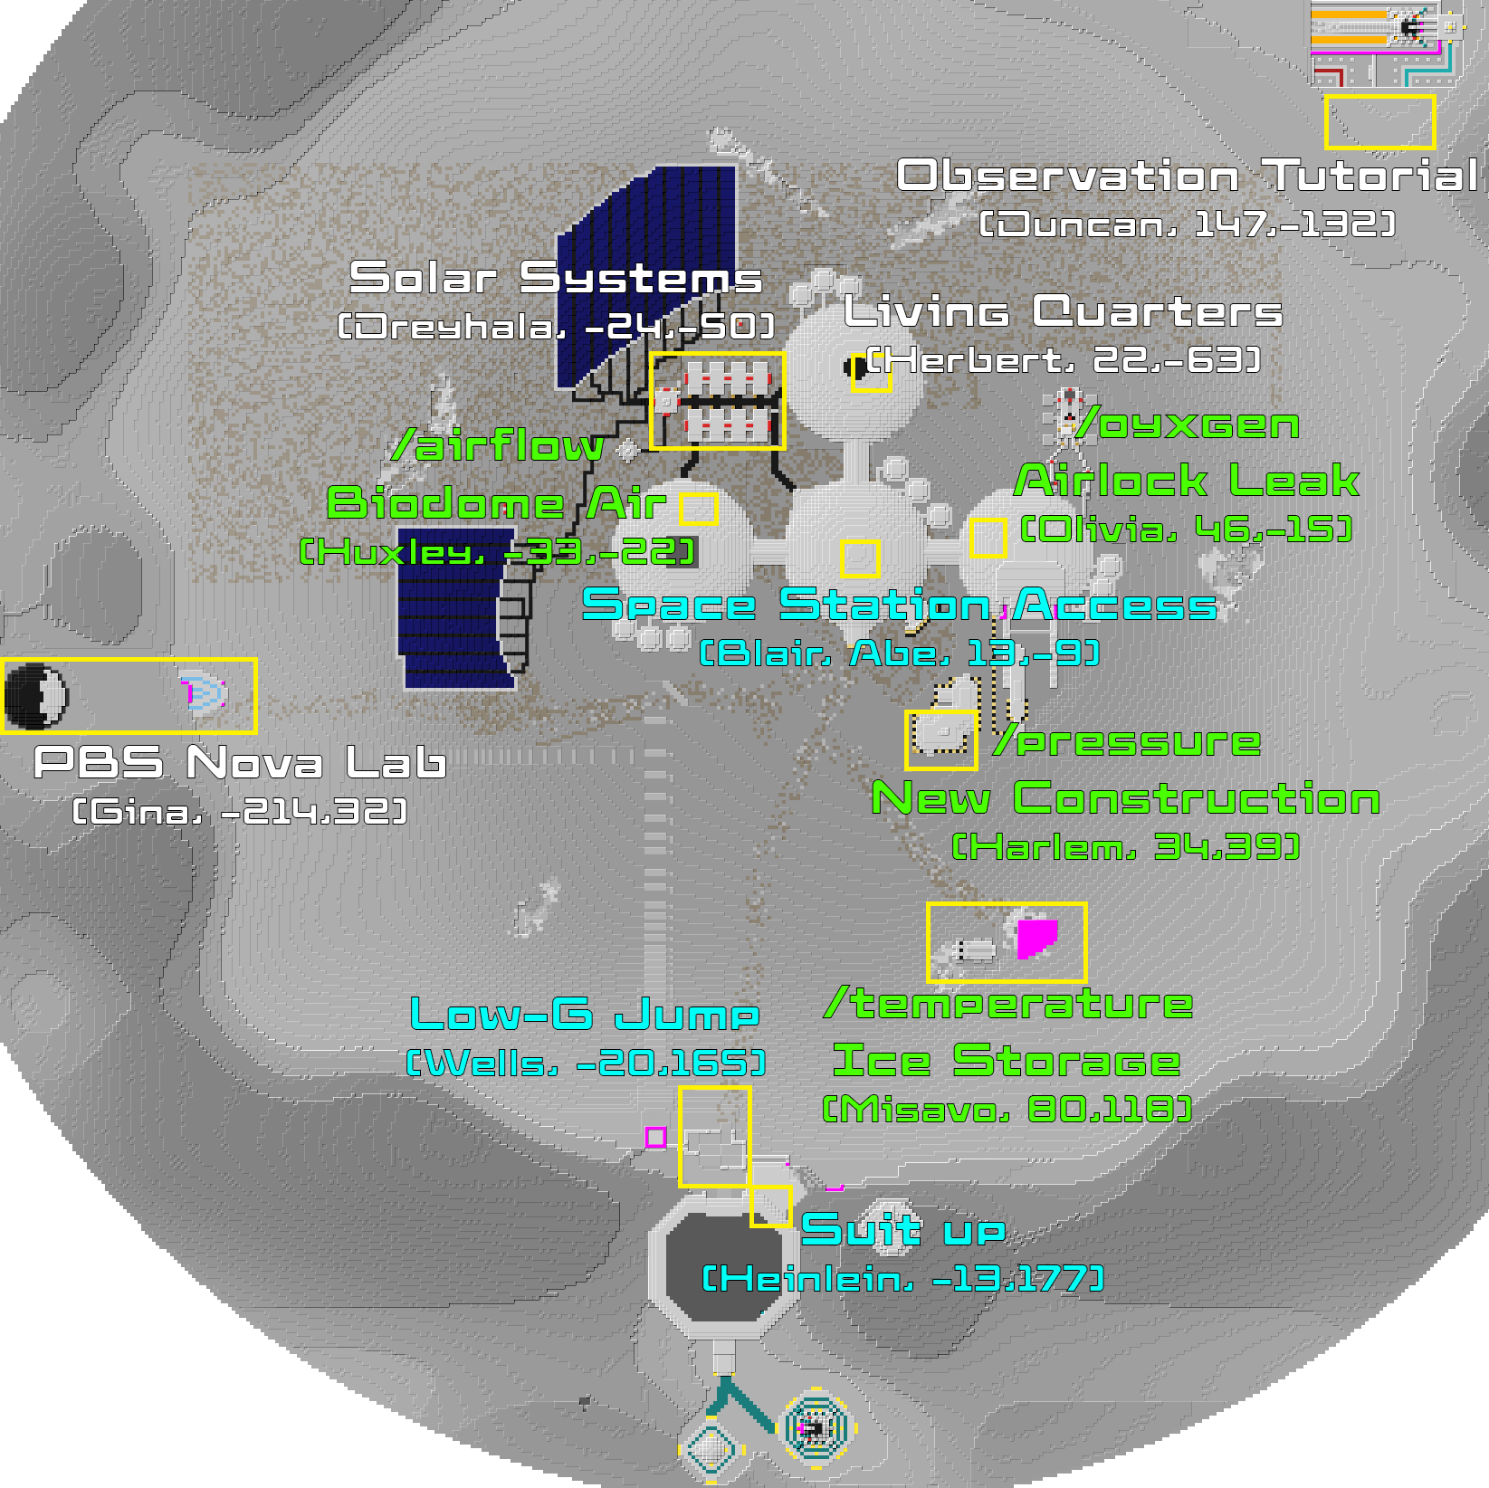

👩🏽‍🔬 NPC's and Their Roles
A non-player character (NPC) is a video game character that is controlled by the game's artificial intelligence (AI) rather than by a player. The NPC’s below are those that are tied to quests on the server or that offer relevant STEM information – there are others who may be present but not mentioned in this guide.
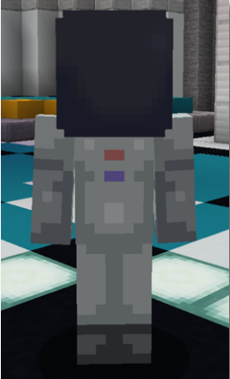 | Located at  x: -23  y: 71  z: 192  ID: 0 | [Recent Arrival] Roger M. – Initiates Welcome to Lunar Base LeGuin! orientation quest and teaches players how to interact with NPCs that they will come across in the future.
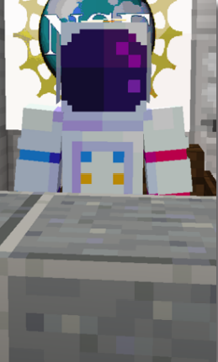 | Located at  x: -13  y: 71  z: 172  ID: 14 | [Facility Administrator] Heinlein R. – Welcomes players to the lunar base and directs them to get suited up in order to go out onto the surface of the moon.
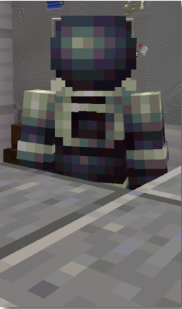 | Located at  x: -6  y: 71  z: 164  ID: 23 | [Facility Administrator] Wells O. – Directs players to go outside and perform a low-gravity jump as well as to find Blair in the central dome of the base.
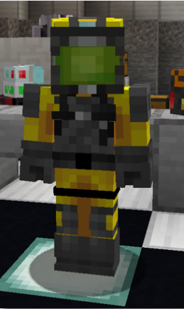 | Located at  x: 10  y: 18  z: -5  ID: 19 | [Facility Overseer] E.A. Blair – Completes Welcome to Lunar Base LeGuin! orientation quest, assigns players Meeting People quest to help find the NPCs associated with specific science tools as well as the science tools-specific quests (see Space Station Access quest above).
 | Located at  x: -25  y: 18  z: -5  ID: 3 | [Head Botanist] John B. – Talks about the role that the head botanist needs to fulfill to keep the plants in the biosphere from dying, directs players to explore the sub-level of the biodome.
 | Located at  x: -32  y: 18  z: -21  ID: 20 | [Facility Biologist] Huxley A. – Associated with the /airflow (or /wind) science tool and will ask players to use their suit instruments to determine if the air flow mechanisms in the biodome are functioning properly. Assigns the Not-So-Solar-Wind quest to players.
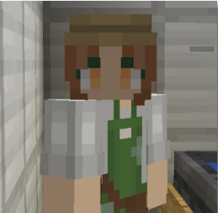 | Located at  x: -14  y: 12  z: 9  ID: 32 | [Nursery Manager] Armina J. – Tells the player about the importance of keeping the plants in the biosphere healthy and details the requirements of her job maintaining the plants.
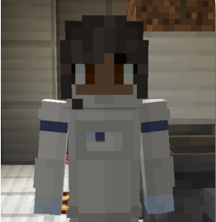 | Located at  x: -42  y: 12  z: 4  ID: | [Station Horticulturist] Estelle B. – Talks about her job sustaining the resources used up by the plants in order to keep the crops growing as efficiently as possible.
 | Located at  x: -50  y: 12  z: -14  ID: 33 | [Mycologist] Eugene V. – Talks about the various implementations of fungi in the biosphere and how they contribute to crop growth.
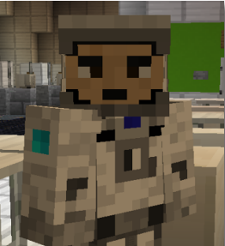 | Located at  x: 25  y: 18  z: -65  ID: 24 | [Facilities Manager] Herbert F. – Located in the Living Quarters, this is the NPC that you must notify of the air circulation system’s malfunctioning during the Not-So-Solar-Wind quest. Speaking to him during the second stage of the quest will complete it.
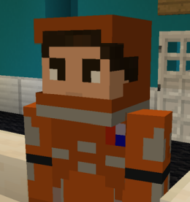 | Located at  x: 25  y: 18  z: -61  ID: 25 | [Material Scientist] Lynn J. – Comments on the large size of the living facilities and how it is better for psychological health and air recycling.
 | Located at  x: 23  y: 22  z: -53  ID: 27 | [Psychiatrist] O. Butler – Details what exactly is needed of a psychiatrist on a space station, including how mentally straining that space travel can be.
 | Located at  x: 3  y: 18  z: -71  ID: 63 | [Life Support] K. Allison – Talks about the details of showering in non-gravity environments as well as on the moon. Highlights that all of the water is constantly recycled.
 | Located at  x: 19  y: 18  z: -54  ID: 28 | [Medic] Janusz Z. – Talks about the challenges surrounding medical treatment in space, and how different the body is in low or no gravity.
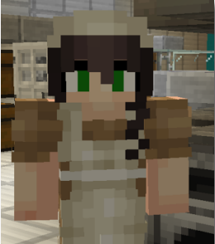 | Located at  x: 24  y: 18  z: -73  ID: 26 | [Medical Doctor] D.B. Webster – Provides information that no one is currently sick or injured throughout the moon base, as evidenced by the empty beds in the medical bay.
 | Located at  x: 8  y: 18  z: -46  ID: 92 | [Physical Therapist] Armstrong – States that muscles break down much faster in low gravity than they do on Earth, so those on the base need to work out more to compensate.
 | Located at  x: 55  y: 14  z: -13  ID: 12 | [Materials Scientist] Olivia C. – Associated with the /oxygen science tool, she will ask players to see how much oxygen is leaking from the Materials Laboratory airlock. Issues the quest A Breath of Fresh Air.
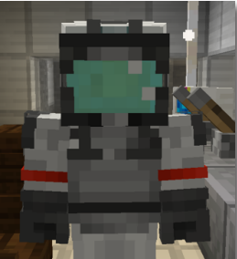 | Located at  x: 61  y: 25  z: -22  ID: 34 | [Computer Engineer] Cyril H. – Describes the importance of upkeep and maintenance of sensors throughout the lunar base, as well as how the 3D printers obtain materials.
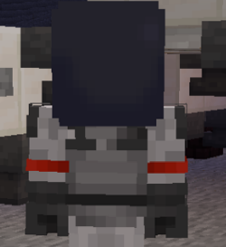 | Located at  x: 39  y: 38  z: 102  ID: 11 | [Head Mechanic] Bob K. – Encourages jumping around while he mans the moon rover that hauls ice.
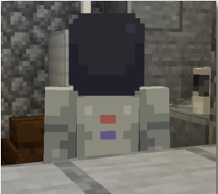 | Located at  x: 67  y: 38  z: 105  ID: 16 | [Seismologist] Misavo I. – Associated with the /temperature science tool and the What’s Cooler Than Being Cool? quest, will ask the player to take the temperature of the ice storage area so that they can calibrate their instruments correctly; the player must go further into the facility and nearer to the ice in order to get the correct temperature.
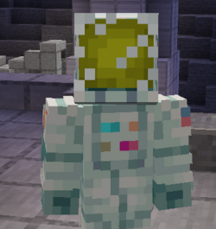 | Located at  x: 37  y: 26  z: 39  ID: 21 | [Construction Engineer] Harlem R. – Associated with the /pressure science tool, assigns the Feeling the Pressure quest, and will ask the player to use their suit to take a pressure reading of the new regolith building he is standing on.
 | Located at  x: -217  y: 73  z: 33  ID: 155 | [PBS Nova] Gina Varamo – Staffs the exoplanet lab area and encourages players to visit the PBS Nova Exoplanet Lab online. Assigns the Exoplanet Lab quest.
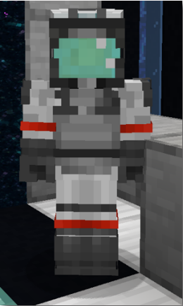 | Located at  x: 18  y: 18  z: -11  ID: 30 | [Launch Director] Abe K. – Checks to see if players have completed the Meeting People quest and assigns the Space Station Access quest, which when completed allows players to progress to new worlds through the Space Station Hub.
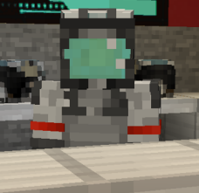 | Located at  x: 148  y: 53  z: -129  ID: 86 | [Instructor] Duncan H. – Welcomes players to participate in the observation tutorial. Currently, the tutorial is completely optional but can be required by instructors on an as-needed basis.

